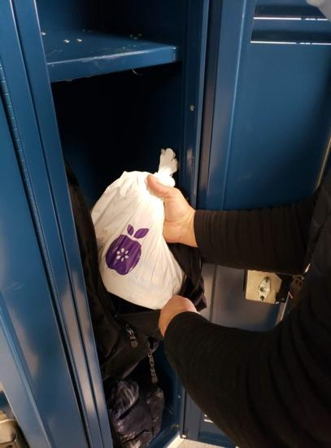
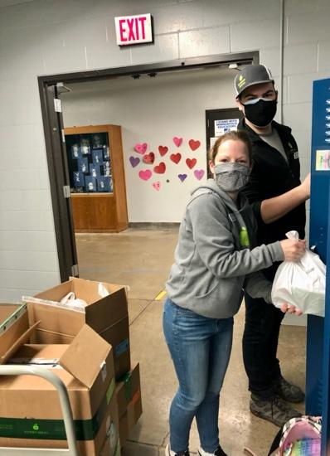

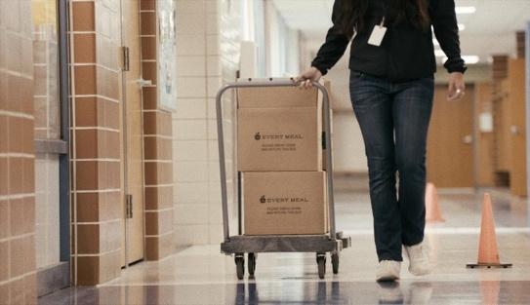
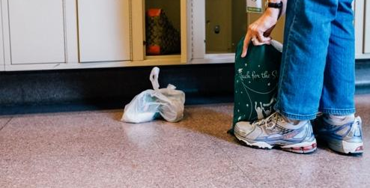

VOLUNTEERS
NEEDED

Our school is in need of volunteer support!

Help support families by volunteering to place Every Meal food bags in students' backpacks or lockers at the end of each week to help provide food for the weekend.

Contact (insert name) below to learn more and sign-up!

