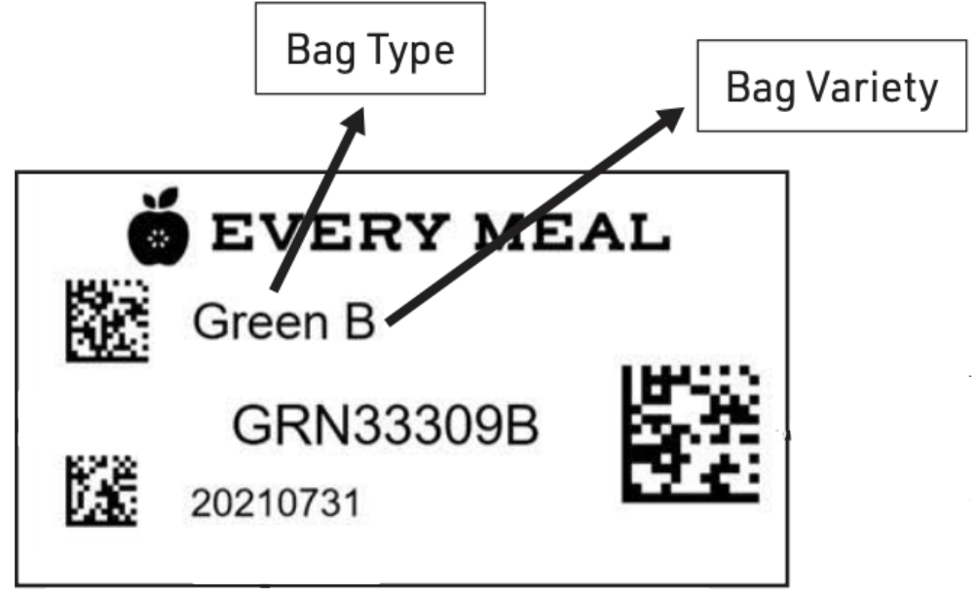

Variety Tracker: used for bag colors where 1-3 students are enrolled, to ensure bag content rotation week to week.

Distribution Date | Bag Type  (Blue, Green, Orange, Purple, Yellow) | Variety Used  (A, B, C, D) |  | Distribution Date | Bag Type  (Blue, Green, Orange, Purple, Yellow) | Variety Used  (A, B, C, D)

Variety Tracker: used for bag colors where 1-3 students are enrolled, to ensure bag content rotation week to week

Distribution Date | Bag Type  (Blue, Green, Orange, Purple, Yellow) | Variety Used  (A, B, C, D) |  | Distribution Date | Bag Type  (Blue, Green, Orange, Purple, Yellow) | Variety Used  (A, B, C, D)

