**Pull-tab flyer instructions**

The pull-tab flyer is a great resource for students to learn more about the weekend food program discreetly. It also pairs well with the **QR code flyer**. This flyer is designed to be hung in more private spots across the school, such as on the inner doors of stalls in a school restroom. The goal is for students to be able to tear off a tab and access the enrollment form easily and discreetly—perhaps even from their mobile device.

1. Pull the document (EM Pull Tab Flyer) up in Word.
2. In your internet browser, pull up your site’s Google Form enrollment form and click the “send” button in the top corner.
   1. Then click the on the image of a paper clip to copy the link.
   2. Check “Shorten URL” and you will receive a short link to paste onto your flyer.
   3. Paste this shortened link into the bolded part on each pull tab that says “insert link here*
3. Print the flyer and cut on the lines so that students can easily tear off a tab.

**Scroll to next page for pull tab flyer.**

**Every Meal**

2723 Patton Road, Roseville, MN 55113 |  **www.everymeal.org**   | 612-568-4003

**Blue Bag**

Tailored for East African dietary preferences, this bag is pork-free and may contain items such as tuna, spaghetti, black-eyed peas, corn flour, fava beans, and tomato products.

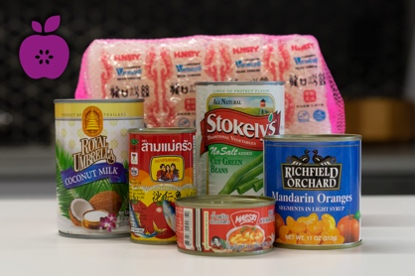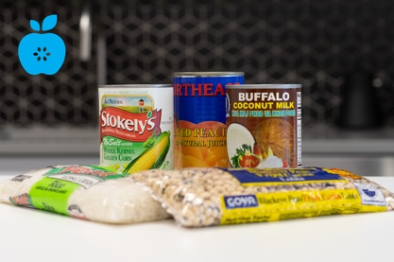

**Purple Bag**

Tailored for Southeast Asian dietary preferences, this bag may contain items such as rice, rice noodles, coconut milk, bamboo shoots, curry paste, green beans, and mandarin oranges.

**Green Bag**

Tailored to offer the widest variety of food items, this bag may contain items such as chicken, tuna, pasta, rice, mac and cheese, chili/soup, and varied vegetables and fruits.

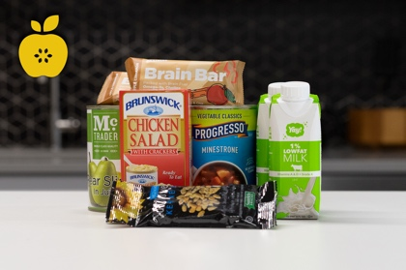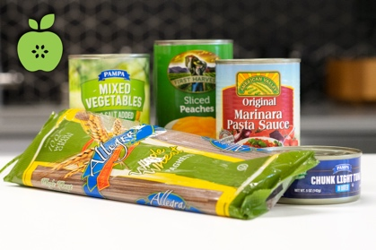

**Yellow Bag**

Tailored with all ready-to-eat items which require little or no preparation, this bag may contain items such as dried fruit, tuna salad, chicken salad, sunflower seeds, granola, oatmeal, and soups.

**Orange Bag**

Tailored for Latino dietary preferences, this bag may contain items such as rice, black beans, pinto beans, corn flour, fideo pasta, enchilada sauce, chipotles in adobo, and diced chiles.

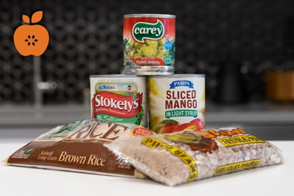

Would you like to take home a FREE bag of nonperishable groceries on Fridays? Use the link to sign up for the Weekend Meal Program. Choose from 5 different bag types!

Tear off a tab to sign up:

**WEEKEND MEAL PROGRAM**

**Insert link here**

**WEEKEND MEAL PROGRAM**

**Insert link here**

**WEEKEND MEAL PROGRAM**

**Insert link here**

**WEEKEND MEAL PROGRAM**

**Insert link here**

**WEEKEND MEAL PROGRAM**

**Insert link here**

**WEEKEND MEAL PROGRAM**

**Insert link here**

