Volunteer Opportunity:
Meal Bag Distribution
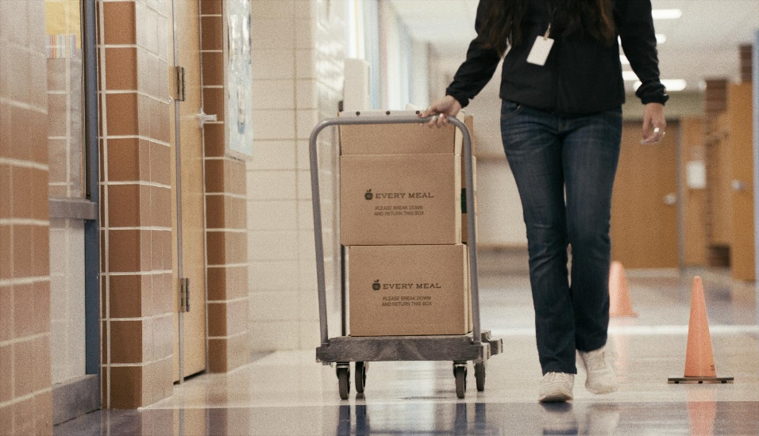

Our school is in need of volunteer support for distributing Every Meal bags to participating students!
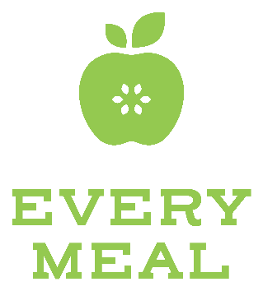
Every Meal is a local non-profit, partnered with
us to help fight child hunger in our community. Students discreetly receive a meal bag placed
in their backpack or locker at the end of each week to help provide food for the weekend.

Distributing meal bags is a hands-on, meaningful way to volunteer and support our students!
Contact (insert name) below to learn more and sign-up.

