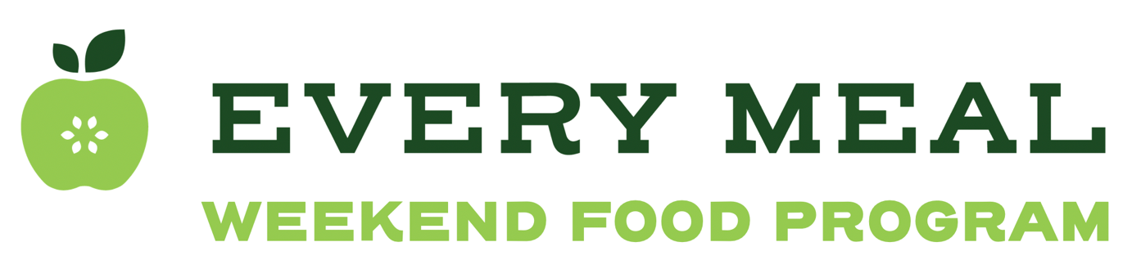

Pull-tab flyer instructions

The pull-tab flyer is a great resource for students to learn more about the weekend food program discreetly. It also pairs well with the QR code flyer. This flyer is designed to be hung in more private spots across the school, such as on the inner doors of stalls in a school restroom. The goal is for students to be able to tear off a tab and access the enrollment form easily and discreetly—perhaps even from their mobile device.

- Pull the document (EM Pull Tab Flyer) up in Word.
- In your internet browser, pull up your site’s Google Form enrollment form and click the “send” button in the top corner.
  - Then click the on the image of a paper clip to copy the link.
  - Check “Shorten URL” and you will receive a short link to paste onto your flyer.
  - Paste this shortened link into the bolded part on each pull tab that says “insert link here*
- Print the flyer and cut on the lines so that students can easily tear off a tab.

Scroll to next page for pull tab flyer.

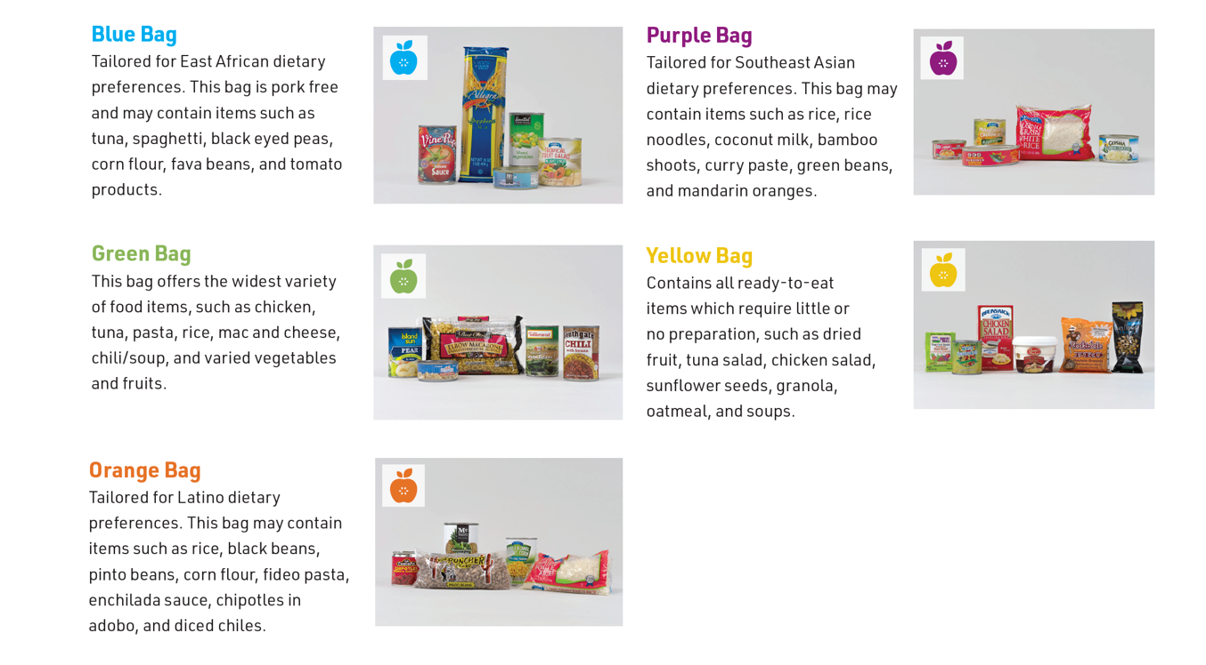

Would you like to take home a FREE bag of nonperishable groceries on Fridays? Use the link to sign up for the weekend food program. Choose from 5 different bag types!

Tear off a tab to sign up:
WEEKEND FOOD PROGRAM  Insert link here | WEEKEND FOOD PROGRAM  Insert link here | WEEKEND FOOD PROGRAM  Insert link here | WEEKEND FOOD PROGRAM  Insert link here | WEEKEND FOOD PROGRAM  Insert link here | WEEKEND FOOD PROGRAM  Insert link here

